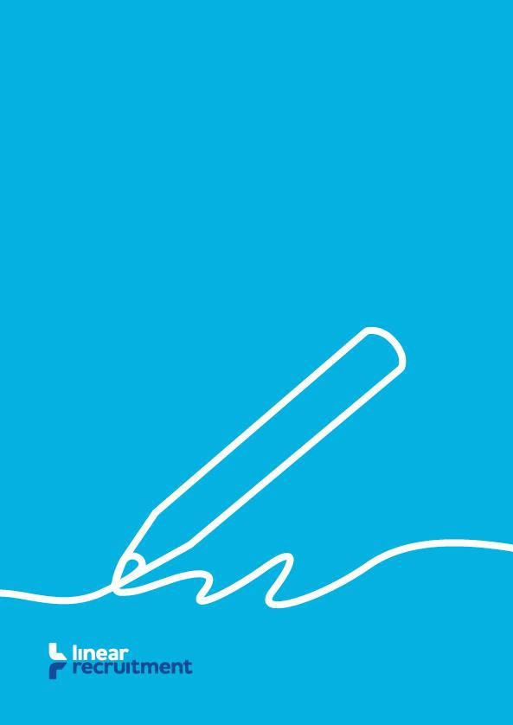
Linear Recruitment: Gender Pay Gap Report
April 2023

What is the Gender Pay Gap Report?

Under the Equality Act 2010, all organisations which employ 250 people or more are required to publicly report the difference in average pay between the men and women they employ.
This document is Linear’s Gender Pay Gap Report and delivers our pay findings along with the steps
we will take to further improve our performance.
We are committed to continually reducing the gender pay gap.

Why is Linear Reporting?

While Linear employs just 50 people for its own business operations, as a labour supplier we engaged temporary candidates through contracts for service. Combined, these exceed 250 people. Temporary candidates are supplied to our clients who work predominantly in the construction industry.
We believe eliminating the gender pay gap is the right thing to do for successful business and a fair society.

Our Results

The results of our Gender Pay Gap Report for this period show a 2.92% mean gender pay gap and a 0.60% median pay gap, compared with a -4.83% mean gender pay gap and a 0.00% median gender pay gap for the preceding year. As a business we employ far more men than women as is typical of the construction industry.

 | Men | Women
 | Pay Rate | Pay Rate | %
Mean Gender Pay Gap | £9.92 | £9.63 | 2.92
Median Gender Pay Gap | £10.06 | £10.00 | 0.60

During this period, we have a mean bonus pay gap of 13.46% and a median gap of -5.14%, compared with a mean bonus pay gap of 19.87% and a median gap of -12.01% during the preceding year¹.

 | Men | Women
 | PAY RATE | PAY RATE | %
Mean Bonus Gender Pay Gap | £1117.02 | £966.70 | 13.46
Median Bonus Gender Pay Gap | £561.51 | £590.35 | -5.14

During this period, 84.98% of our employees who are men received a bonus, compared with 91.10% who are women. There are more men employed across all quartiles.

 | Men | Women
 | % | %
Proportion receiving a bonus | 84.98 | 91.10
Proportion in lower quartile band | 55.87 | 44.13
Proportion in lower middle quartile band | 53.04 | 46.96
Proportion in upper middle quartile band | 55.06 | 44.94
Proportion in upper quartile | 59.92 | 40.08

1 Preceding year’s Mean and Median bonus figures reviewed for 2023 submission.

What We’re Doing

In order to reduce the Gender Pay Gap further, we are committed to taking pro-active steps including:

- Continuing to recruit people on merit and suitability for each role
- Setting Gender Pay Gap KPIs to ensure our pay gap closes over time
- Implementing a Gender Pay Gap review schedule so we can monitor our performance
- Continuing to train our employees through the Recruitment & Employment Confederation
- Promoting equal gender representation in the construction industry
- Reviewing our bonus scheme
- Conducting further analysis on our Gender Pay statistics
- Being transparent with our gender pay information
- Offering flexible working arrangements to encourage more women to work for and with us

Declaration

I declare the information detailed in this report has been calculated in accordance with the Equality Act 2010 (Gender Pay Gap Information Regulations 2017) and is accurate.

Gareth Tomkins
Managing Director Linear Recruitment Ltd

